SPSI Email Signatures 2026: Setup Guide
This guide covers adding your new 2026 signature to Outlook (desktop and mobile), adding the same signature to Acumatica, and connecting your email to Acumatica so emails you send from Acumatica come from your own mailbox.
What you need: the company email with your signature file attached (YourName_signature.html).

Steps for all users: copy your signature

Step 1: Open the email with your signature file
1. Find the company-wide email that contains your HTML signature file.
2. Open the attachment with your name in the file name (for example, YourName_signature.html).
3. Download the file to your computer.

Step 2: Open the file in a browser (Google Chrome or Microsoft Edge)
1. On a computer, double-click the file. It opens in your web browser. Chrome or Edge both work.
2. On a phone, tap the file to open it in your browser.
3. You should see your signature. It should look like the example below, with your own name, title and numbers.
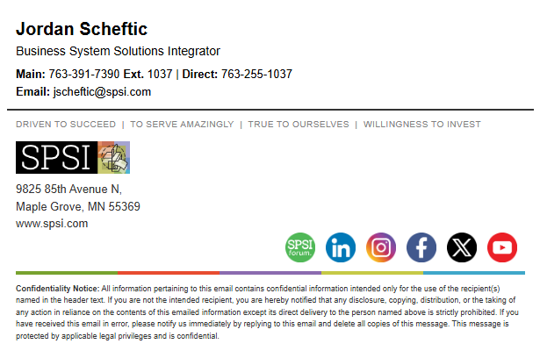
What the 2026 signature looks like

Step 3: Copy the signature
1. Select the whole signature: press Ctrl + A (Windows) or Command + A (Mac). On a phone, tap and hold, then drag the handles to cover the whole signature.
2. Copy it: press Ctrl + C (Windows) or Command + C (Mac). On a phone, tap Copy.

Outlook on your computer

Which Outlook do I have?
Look at the top-right corner of Outlook for the New Outlook switch. If the switch is on, you have New Outlook. If it is off, or you see a File tab in the top-left corner, you have Classic Outlook.

Classic Outlook
1. Do the Steps for all users section first so your signature is copied.
2. Open Outlook and go to File > Options > Mail > Signatures.
3. Click New, type a name for the signature (for example, SPSI 2026) and click OK.
4. Click inside the editing box and press Ctrl + V to paste.
5. Check that it looks like the example above: logo, social icons and the colored line under the icons.
6. Set it as your default: under Choose default signature, pick your email account, then choose the signature for New messages and for Replies/forwards.
7. Click OK to save.

New Outlook
1. Do the Steps for all users section first so your signature is copied.
2. Open Outlook and click Settings (the gear icon, top right).
3. Go to Accounts > Signatures. You can also type signature in the settings search box.
4. If you have more than one account, pick your SPSI account.
5. Click + New signature, type a name, click in the editing box and press Ctrl + V to paste.
6. Check that it looks like the example above.
7. Set it as your default: under Select default signatures, choose it for New messages and for Replies/forwards.
8. Click Save.
Note: New Outlook saves the signature to your Microsoft 365 account, so it also shows up in Outlook on the web.

Outlook and email on your phone
Heads up: Phone email apps keep signatures mostly as text. iPhone Mail and the Gmail app only support text signatures, and the Outlook app may drop the logo and icons. That is expected. If the pasted signature looks messy, type a short text version instead: your name, title, SPSI, Inc., and your phone number.

Outlook app (iPhone and Android)
1. Do the Steps for all users section on your phone first so your signature is copied.
2. Open the Outlook app and tap your profile picture or the menu (top left).
3. Tap Settings (gear icon).
4. Under Mail, tap Signature. If you have more than one account, turn on Per Account Signature and pick your SPSI account.
5. Tap and hold in the text box, then tap Paste.
6. Tap the check mark or back arrow to save.

iPhone Mail app
1. Do the Steps for all users section on your phone first so your signature is copied.
2. Open the Settings app. On iOS 18 or later go to Apps > Mail. On older versions go to Mail.
3. Tap Signature (under Composing). If you have more than one account, tap Per Account.
4. Tap and hold in the text box, then tap Paste.
5. If the formatting looks off, shake the phone and tap Undo to remove the formatting.
6. Go back to save.

Gmail app (iPhone and Android)
1. Open the Gmail app and tap the menu (top left).
2. Tap Settings, then tap the account to change.
3. Tap Mobile Signature (on iPhone: Signature settings) and paste or type your signature. Gmail keeps this as plain text.
4. Tap OK or go back to save.

Acumatica: connect your email and add your signature
Emails you send from Acumatica (quotes, orders, invoices, activities) use your personal email account and your Acumatica signature. Both are set up in one place: My Profile > Email Settings. Do this on a computer.

Step 1: Open My Profile
1. Sign in to Acumatica.
2. Click the person icon in the top-right corner (1).
3. Click MY PROFILE (2).
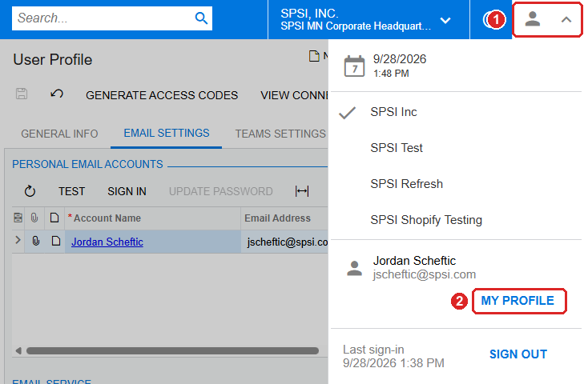
Person icon (1) > My Profile (2)

Step 2: Connect your email account (Sign In)
1. Click the EMAIL SETTINGS tab (1).
2. Under Personal Email Accounts you should see your email account. If the list looks empty, click the Refresh arrow (2). If your account still does not show, click TEST, type your email address and click Test. Then click the Refresh arrow again and your account will show.
3. Click your account row to select it (3).
4. Click SIGN IN (4).
5. A Microsoft sign-in window opens. Sign in with your SPSI email and password (and approve the sign-in on your phone if asked). If Microsoft asks you to accept permissions for Acumatica, click Accept.
6. When the window closes you are connected.
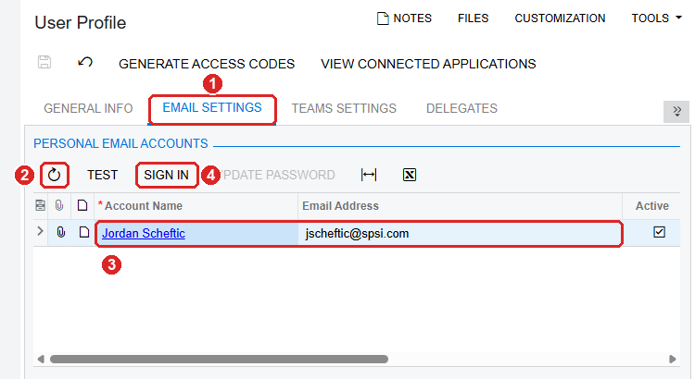
Email Settings (1), Refresh (2), your account (3), Sign In (4)
Note: If nothing happens when you click Sign In, your browser may be blocking the pop-up. Allow pop-ups for spsi.acumatica.com and try again. You only need to sign in once. If you change your email password, come back here and click Sign In again.

Step 3: Set your default email account
1. Under Email Service, click in Default Email Account and start typing your name (1).
2. Pick your account from the list (your name and email address).
3. Click Save (the disk icon, top left) (2).
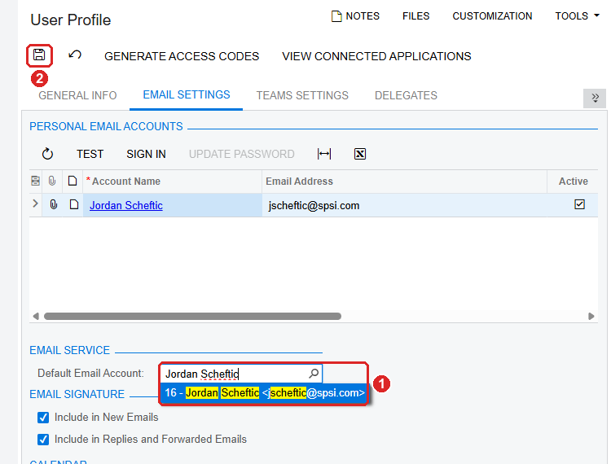
Default Email Account (1), Save (2)
This tells Acumatica to send your emails from your own mailbox. If it is left blank, emails from Acumatica come from the company's general account instead.

Step 4: Add your signature
1. Copy your signature first (Steps for all users, Step 3).
2. Under Email Signature, check Include in New Emails and Include in Replies and Forwarded Emails (1).
3. Click inside the signature box at the bottom of the page (2). If there is an old signature there, press Ctrl + A to select it all, then Delete.
4. Press Ctrl + V to paste your new signature. Check that the logo, icons and colored line show up.
5. Click Save (the disk icon, top left) (3).
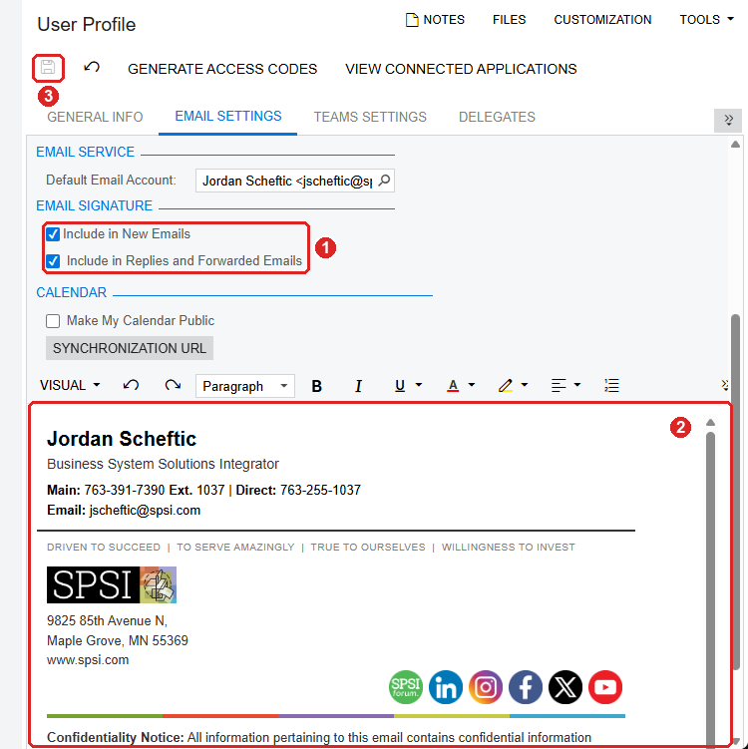
Signature options (1), signature box (2), Save (3)

Another way: paste the HTML code
Use this if the pasted signature looks wrong in Acumatica. It copies the signature file exactly.
1. On your computer, right-click your signature file and choose Open with > Notepad.
2. In Notepad, press Ctrl + A, then Ctrl + C, to copy all of the code.
3. In Acumatica, click VISUAL above the signature box (1) and choose HTML (2).
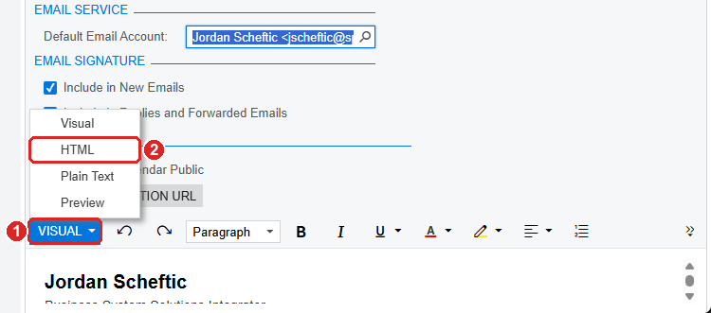
VISUAL (1) > HTML (2)
1. Click inside the code box (2), press Ctrl + A, then Delete, to clear the old signature.
2. Press Ctrl + V to paste the code.
3. Click HTML (1) and choose Visual to check that the signature looks right.
4. Click Save (the disk icon, top left) (3).
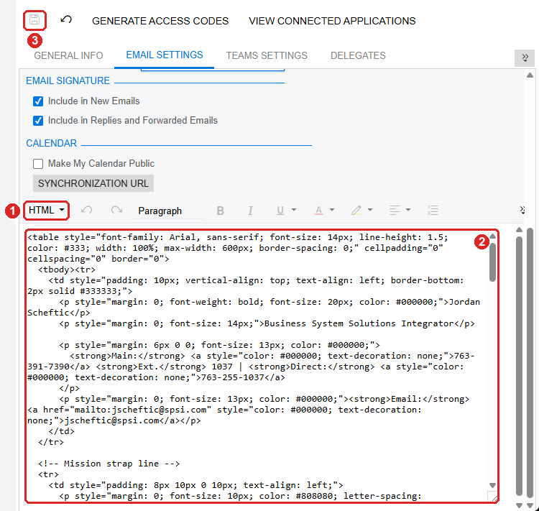
HTML mode (1), code box (2), Save (3)

Test your signature
1. Start a new email in Outlook and check that your signature appears and looks right.
2. Reply to an email and check it again.
3. If something looks wrong, delete the signature and repeat the copy and paste steps.

Tips
- Paste with the keyboard: copy with Ctrl + C and paste with Ctrl + V. Right-click paste can drop the formatting.
- Copy problems: if the signature does not copy correctly from Chrome, open the file in Microsoft Edge and try again.
- Colored line lower than the icons: if this happens after pasting in Outlook, hover over the line and drag it up as far as the editor allows.
- Do both: set up your signature on your computer and on your phone.
- Need help: email jscheftic@spsi.com.

